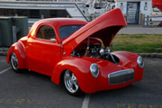
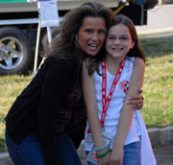
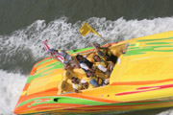
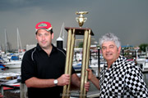
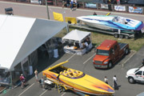
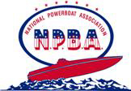
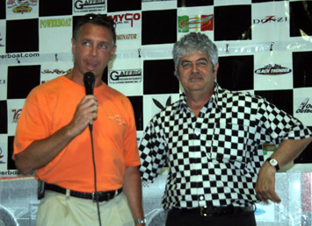
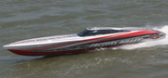
NEW….NEW….NEW….
As I was reading a recent magazine article which made many referrals to the National Powerboat Association (NPBA) and its races from the 70’s and 80’s, I feel compelled to recognize the many drivers, throttlemen, and navigators who got their start in or competed on that circuit….before we changed to producing poker runs. Some of you “new” powerboat enthusiasts will now be able to “connect the dots” with some of the names and teams of yesterday and how prominent some have become in the sport/industry of today. Billy Frenz

The Inaugural Ceremony to Award Inductees into The NATIONAL POWERBOAT ASSOCIATION’s HALL OF FAME “Offshore Powerboat Racing Champions” will take place at The NEW YORK CITY POWERBOAT POKER RUN on Friday Night, June 13, 2008. Charlie McCarthy and Rich Luhrs will each make Power-Point presentations on the history of our sport!
VOTE FOR YOUR FAVORITE NPBA POWERBOATER
e-mail: Billy@Nationalpowerboat.com
Candidates so far are:
Joe Sgro FEVER RACE TEAM, OUTERLIMITS RACING
Ron Barette OVERDOSE, MAXED OUT RACE TEAM 1979
Jeff Gerardi ACAPULCO GOLD, FREEZE FRAME RACING
Pete Mazzo DYNAMITE RACE TEAM, NO DISCIPLINE 1983
Ray Patneude VELOCITY
Roger Munn JOLLY ROGER RACE TEAM 1978
Steve Schroeder INDIGO RACING 1979
John D’Elia SPECIAL EDITION 1983
Chris & Mark Lavin JESSE JAMES RACING 1983
Stu Hayim AMERICAN EXPRESS, RECOVERY RACING 1985
Rick Felson HIGH RISK RACING 1985
Larry Smith OUTRAGEOUS RACE TEAM 1978
Billy Frenz HOT SHOT, OUTRAGEOUS 1975
Pete Aitken TOP SHELF, BLACK DUCK RACING 1975
Tom Akouri HIGH ROLLER, BLACK DUCK 1975
Joey Impresscia EASTCOAST MARINE 1979
Bob Idoni FAYVA SHOES RACING 1977
Charlie McCarthy TOP BANANA RACE TEAM 1977
Billy Martin BOUNTY HUNTER RACING
Reggie Fountain EXECUTIONER RACE TEAM 1981
Rich Luhrs TEAM SHADOW 1981, CONQUEST
George Linder TEAM SHADOW 1981
Paul Fiore HUSTLER RACING
Guy LaMotta DRY MARTINI RACE TEAM 1975
Tom Caruso TOTAL MARINE 1985
John MacKenzie H.M.S. DEA WON
Kurt Burger SMOKEY AND THE BANDIT RACING 1978
Tim Ciasulli MAXON RACE TEAM
Fred Talarico BIG SHOT RACING
Joe DeTore SUPERBOAT M77 RACING, 1977
Tony Caligure OCEAN OUTBOARD
Rolf Papke STILETTO 1980
John Coen SUPERBOAT RACE TEAM 1977
Peter Meyer LADY L RACING, INSTIGATOR
Sal Sciandra AWESOME RACING 1982
Steve Berk GREAT ADVENTURE, BURKES LAW 1979
Jim Laznovsky EXTRACTOR 1981
Jim McIntyre MAD MAC 1985
Mark Tangas PROFIT TAKER 1985
Richie Zul ZUL RACING 1986
Rudy DiPietro SCARAB 1983 Rich Dancisin TOWN AND COUNTRY RACING 1983 PG 3

