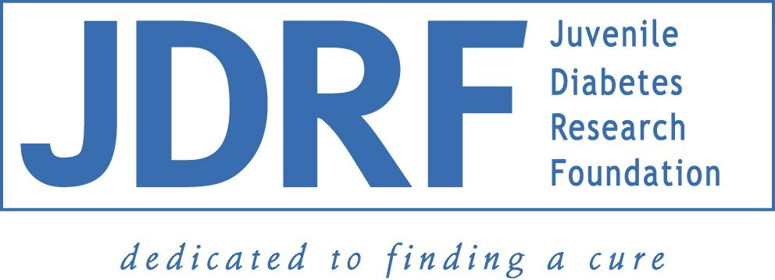

June 22, 2004

Sarasota Offshore Showdown Foundation For Kids
15 Paradise Plaza
#306
Sarasota, FL 34239-6905

ATTN: Board of Directors

RE: Sarasota Offshore Showdown

Gentlemen,

We regret to inform you that the Board of Directors of the Florida Suncoast Chapter of The Juvenile Diabetes Research Foundation has determined that JDRF must be removed from any and all affiliation with the Sarasota Offshore Showdown Foundation For Kids and the Sarasota Offshore Showdown.

In order to protect and preserve the good standing of JDRF, both in Sarasota and the worldwide JDRF community, it is of unanimous decision of the chapter to no longer be a benefiting charity of the Sarasota Offshore Showdown.

All logo representation must hereby be removed from all printed material, web based material, and any location not specifically addressed. No verbal associations will be permitted, and if necessary, a press release (releases) will be issued if JDRF senses any confusion or misrepresentation among our sponsors or supporters.

Additionally, The Florida Suncoast Chapter of the Juvenile Diabetes Research Foundation absolves itself from any and all liability or responsibility for actions taken by the officers of the Sarasota Offshore Foundation For Kids and the Sarasota Offshore Showdown.

Any questions or clarifications of this separation may be directed to either Stephen DeMarsh, President, Florida Suncoast Chapter of the Juvenile Diabetes Research Foundation, at sdemarsh@scgov.net, or Sara Rankin, Executive Director, Florida Suncoast Chapter of The Juvenile Diabetes Research Foundation at srankin@jdrf.org.

Thank you for your prompt attention to this matter.

Sincerely,

Steve DeMarsh Sara Rankin
President Executive Director
JDRF JDRF
Florida Suncoast Chapter Florida Suncoast Chapter

