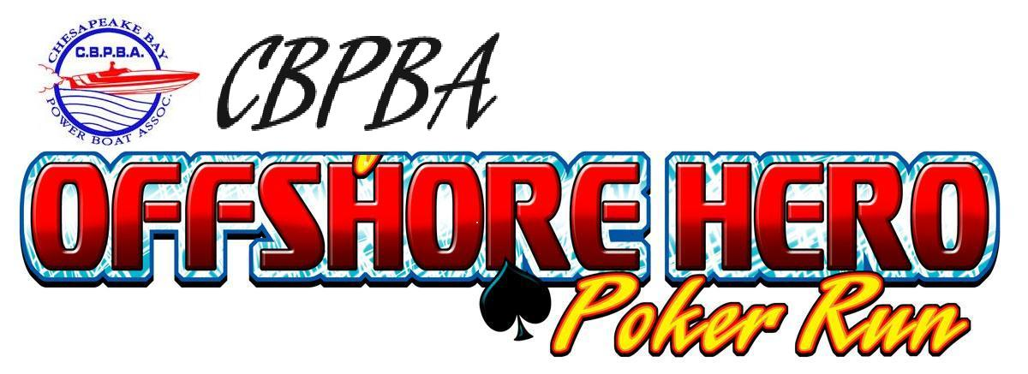

Saturday October 2, 2010

The Official Warm Up to the Solomon’s Offshore Grand Prix

Registration Form

Name: Email:

Address:

City: State: Zip:

Phone: (H) Phone: (C)

Boat Name:

Boat Length: Manufacturer:

Captain’s Package for CBPBA Member (One per boat required) - $250
Includes: (2) Meals (Breakfast, Lunch and Afternoon Snacks), (2) T-Shirts, (1) Helicopter Photo,
(1) Event Video DVD and (1) Poker Hand.
Captain’s Package for Member Volunteering for the Race Event on Sunday - $225

Captain’s Package for Non-Member - (Includes CBPBA Membership $75) - $325

Crew Chief, Throttle man, Navigator or Crew Member Package - $50
Includes: (1) Meal (Breakfast, Lunch and Afternoon Snacks)
Additional Poker Hand - $25

Additional (T-Shirts - $15) (Long Sleeve T-Shirts - $20) (Sweat Shirts - $30)

Late Registration Fee - $25 (For Registration after September 24, 2010)

Total Amount Due: $

*****Free overnight slips will be offered to all participants at Vera’s Marina*****
Slips include water and electric and a shuttle to and from the hotels in Solomon’s.

Will you require a slip at Vera’s White Sands Marina? YES or NO
If Yes: Will you need Electric and what Amperage?

Make Checks Payable to: CBPBA
Send to: Jim Voege 277 Michener Ct E Severna Park, MD 21146
Or you can use the link for Paypal on www.cbpba.com under the Solomon’s Offshore Hero Poker Run

**** Every Captain MUST:
1. Be club member. If you are not, a Club Membership must also be purchased and included.
2. Provide proof of boat insurance to participate in the event. No exceptions. Please provide a photocopy of your declarations page along with your registration form.

Cancellation Policy: In the chance that you cannot make the event, your registration fee will be refunded minus a non-refundable fee for food.

