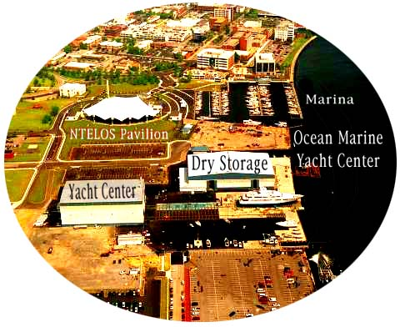
Ocean Marine Yacht Center / March of Dimes

POKER RUN & CAR SHOW FOR FUN

Saturday May 20th, 2006

- 08:00 AM: OM Marina Fuel Docks open

  - Registration Desk & Ditty Bag Pick up
  - 09:00 AM Coffee & Doughnuts
  - 09:30 AM Captains Meeting
  - 10:00 AM POKER RUN Departs (Returns 4 PM)
  - 10:30 AM – 01:00 PM AUTO / CAR & TRUCK SHOW “SET UP”
  - 01:00 PM – 04: PM AUTO / CAR & TRUCK SHOW

- 02:00 PM: Beer Truck arrives and Music Begins

  - 04:00 PM – 05:30 PM BBQ CHICKEN; SILENT AUCTION STARTS; AND CARD TABLE OPENS TO DRAW CARDS
  - 05:30 PM – 06:30 PM BOATERS VOTE ON CARS FOR PRIZES
  - 05:30 PM – 06:30 PM CAR OWNERS VOTE ON BOATS FOR PRIZES
  - 06:30 PM – 07:30 PM AWARDS PRESENTATION
    - 08:00 PM: Beer Truck Departs and Gas Pumps close

